2016 Public Awareness Plan
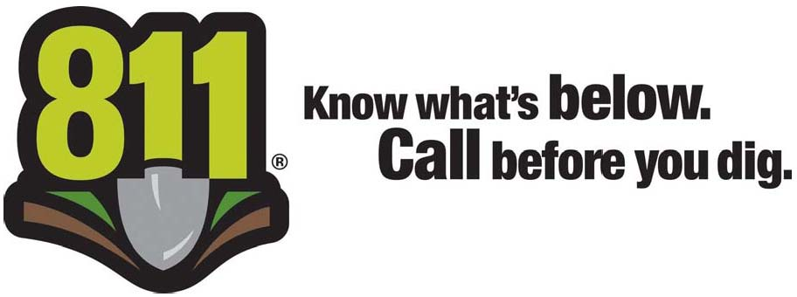

The Code of Virginia requires members of the notification center (utility operators) to be responsible for developing and implementing a public awareness program.
Each year, VA811 and the State Corporation Commission (SCC) participate in a joint education campaign throughout Virginia. This is done to supplement the activities done by VA811 member utilities.
In our efforts to implement this program, the Louisa County Water Authority, is mailing this flier to each customer and will also have this information available on our website www.louisacountywaterauthority.org.
Before you dig, please contact Miss Utility at 811 or (800) 552-7001 or go online to www.va811.com.
Virginia 811 or Miss Utility is the “one call” Virginia communications center for excavators, contractors, and property owners. They notify participating utilities of the upcoming excavation work so they can locate and mark any underground facilities in advance to prevent possible damage to underground utility lines, injury, property damage and service outages.
Dialing 811 before you dig is the law
Respect and protect the marks…..Please excavate carefully!

